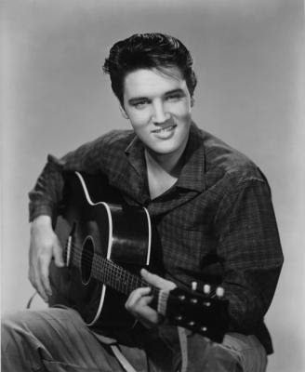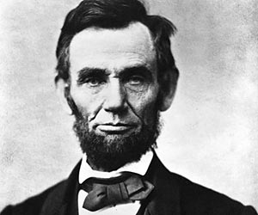Hispanic Heritage Month Presentation

**Objective:** *Create a PowerPoint presentation or Prezi about a famous Latino or Hispanic.*

1. Decide whose biography you will do research on. Your person should be someone who has contributed something of importance to society or history and has become famous because of it.

**Have this person approved!**

1. 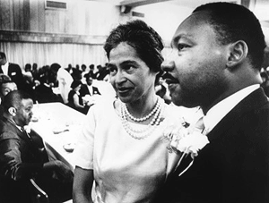Create an 8-slide PowerPoint presentation or 8 Prezi slides about the person you have chosen to research.

***Slide 1:*** Introduction Slide

***Slide 2:*** Background Information

* Where/when was this person born?
* Childhood

***Slide 3:*** Becoming Famous

* What did this person do for a living?
* What qualities or traits do you believe made this person famous?
* What did this person do to become famous?

***Slide 4:*** Impact on Others

* How has this person made an impact on others’ lives?
* In what ways was his/her life remarkable, admirable, or even despicable?
* Was this person a hero? Why or why not?

***Slide 5:*** Decisions/Lessons

* Did this person make any major mistakes or bad decisions?
* What are some important lessons you or any other person might learn from the way this person lived?

***Slide 6:*** Quotes

* Famous quotes from this person/about this person
* What do the quotes mean to you?

***Slide 7:*** Other/Your choice

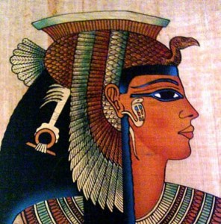

***Slide 8:*** Sources

1. You must have pictures ON EACH SLIDE! Pictures must be clear and appropriate. They must add to the purpose and design of the slides.
2. Slides should be clear, easy to read, and well balanced. Slides should also contain correct spelling and grammar.
3. 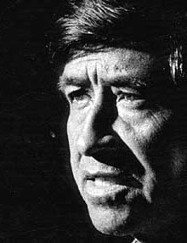When you present to class: 1. Speak clearly. 2. Explain each slide thoroughly. 3. Make the presentation easy to understand.
4. **You must submit your powerpoint or prezi by October 8th 2019 11:59pm.** You will be given multiple days to work on it in the library.
5. To submit your powerpoint go to [www.SrRivera.weebly.com/enlaces](http://www.SrRivera.weebly.com/enlaces) and upload your presentation to the onedrive folder. If you are doing a prezi you must email Sr. Rivera the link to your prezi by the deadline.

RUBRIC

|  |  |  |  |  |  |
| --- | --- | --- | --- | --- | --- |
| Creativity | | Presentation was engaging, interesting, and created curiosity. | | | /10 |
| Content | | You brought your topic to life with complete, thorough, and **appropriate** information. | | | /10 |
| Visual | | Your visual was well crafted and helped the class understand your information. | | | /10 |
| Presentation | | Presentation was well given. You understood the material and spoke clearly to the audience. | | | /10 |
| Use of Tools | | You demonstrated proper use of PowerPoint/Prezi tools. (Formatting, Animation, Transitions, etc.) | | | /10 |
| Total | | | | | /50 |
| ARTS/ENTERTAINMENT | ARTS/ENTERTAINMENT | | SPORTS | POLITICS/GOVERNMENT | | |
| Frida Kahlo | Jorge Ramos | | Manu Ginobili | Honorable Sonia Sotomayor | | |
| Isabel Allende | Lalo Alcaraz | | Laurie Hernandez | Marco Rubio | | |
| Carlos Santana | Javier Bardem | | Monica Puig | Evo Morales | | |
| Tito Puente | Ricky Martin | | Ron Rivera | Simón Bolívar | | |
| Sofia Vergara | Selena Quintanilla | | Andres Iniesta | Alexandria Ocasio-Cortez | | |
| Lin-Manuel Miranda | Camila Cabello | | Sergio Ramos | Eva Perón | | |
| Ozuna | Michael Peña | | Josef Martínez |  | | |
| Bad Bunny | Cheech Marin | | Roberto Clemente |  | | |
| Gabriel Garcia Marquez | Wilmer Valderrama | | Yasiel Puig |  | | |
| Pablo Neruda | Cesar Millan | | Sammy Sosa |  | | |
| Celia Cruz | America Ferrera | | Deyna Castellanos |  | | |
| Gabriel Iglesias | José Andrés | |  |  | | |
| Luis Guzman | Miles Morales | |  |  | | |
| John Leguizamo | Salvador Dalí | |  |  | | |